Possible Placements :

- Local Sports Authorities
- District Sports Leagues
- State Cricket Associations
- Railway and Defence Sports Centers
- National and International Fitness Centres
- Rehab Health Facilities
- Corporate Sports Leagues

Note : This Program is affiliated to two foreign universities, one in Italy, and another one is in Switzerland where the qualified, selected and affordable students will be sent for advanced studies in Sports & Health Sciences as well as Ph.D.programs.

Professor Enrico M. Staderini
Professor in Biomedical Technologies
Western Switzerland University of Applied Sciences
Haute Ecole d'Ingénieurs et de Gestion du Canton de Vaud (HEIG-VD/HES-SO)
tél: +41 76 2059250 - +41 22 534 9705
email: enrico.staderini@heig-vd.ch

For Details Contact
School of Health Sciences & Research
Jawaharlal Nehru Technological University
Kakinada-533003
East Godavari Dist. Andhra Pradesh
email: drprasadusa@gmail.com
email: shsjntuk@gmail.com
Mobile: +91-7702572555
Office: +91-8121668979
Landline: 0884-2300906
Call between 9 am to 5 pm (Except Holidays)

Course Content:

- Basic Medical Sciences
- Epidemiology& Biostatistics
- Sports Nutrition & Ergogenic Aids
- Exercise Physiology
- Fitness, Health and Sports
- Basic Instrumentation & Engineering
- Sports Biomechanics & Kinesiology
- Sports Physical Medicine
- Sports Administration & Ethics
- Sports Psychology
- Neuro Science in Sports
- Sports Emergency & Management
- Sports Journalism & Mass Media
- Sports Rehabilitation
- Sports Injuries Prevention & Management

“Compared to other Sports related courses in India, our course content is an advanced and in depth academics with hands on training for the students par with International standards.”

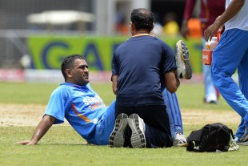

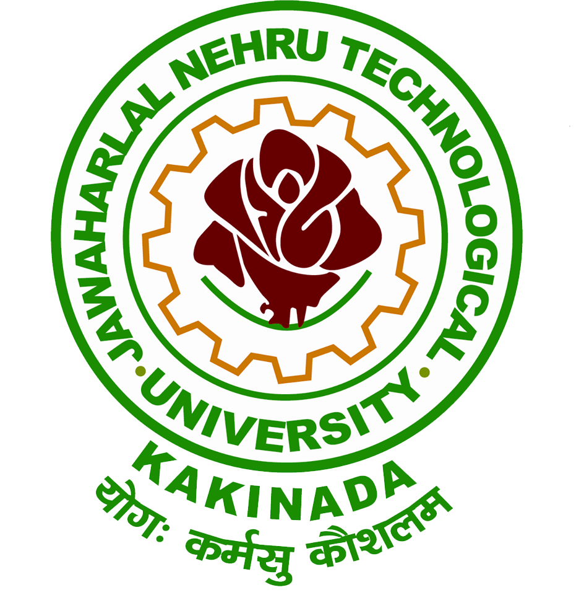

Jawaharlal Nehru Technological University KAKINADA
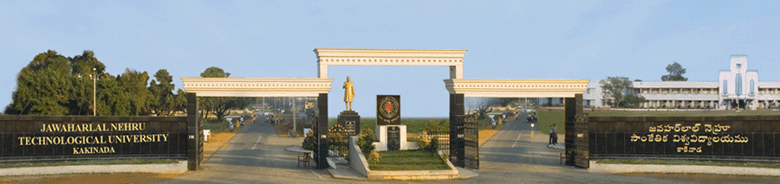

Institute of Science & Technology

School of Health Sciences & Research

MS- PG DEGREE PROGRAMME

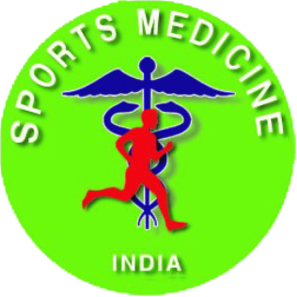

Sports & Health Sciences
(SPORTS MEDICINE)

